EPA-SL Engaged Nature Clubs to Strengthen Environmental Education In Secondary Schools, Freetown
E
By: Amadu Shaw
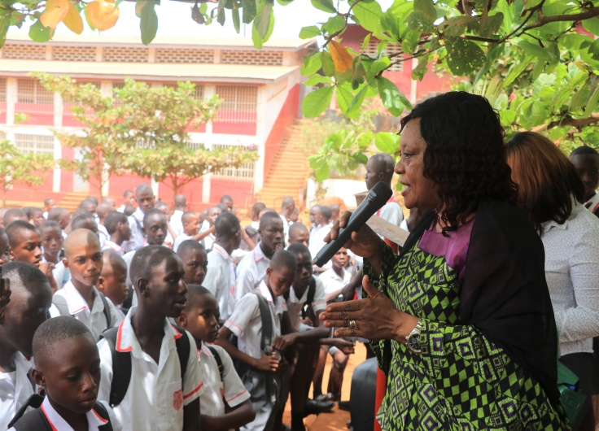
ffective public participation in environmental governance and management may not be easily attainable if members of the public lack the requisite understanding as to what environmental protection for sustainable development is all about. The Environment Protection Agency Sierra Leone (EPA-SL) over the years established environmental clubs in various secondary schools across the country with the objective to serve as a conduit to reach out to young pupils and stimulate their interest in environmental management and sustainability. The clubs comprised of students and teachers that are usually engaged by EPA officials during school assemblies to educate them on environmental challenges. For instance, last year, six secondary schools in the western area were visited and six has been visited this year with the aim to revamp and strengthen environmental education. This is one of the key mandates of the Agency to raise awareness and sensitize principal/Teacher coordinators and pupils on environmental issues including Climate change.
The EPA Deputy Director of Public Relations & Intersectoral Collaboration, Mrs. Ramatu Massaquoi and other officials engaged school pupils at Albert Academy Secondary School, Freetown.
Inter-schools quiz and debate competitions on issues with potential impact on the environment are often organised to impart the pupils with the requisite knowledge and to inspire them to serve as environmental ambassadors in the future. There is a moral proverb which says ‘Catch Them Young’, this discernable approach is used to transform the mind-set of the students to embark on significant environmental activities such as tree planting, waste disposal management, awareness raising, etc. within their respective schools and communities. The pupils will also be educated to play greater roles beyond the academic sphere in influencing their peer groups, parents and communities in promoting best practices thereby achieving a sound and sustainable environment. Environmental education is not just about learning but comprehending the challenges
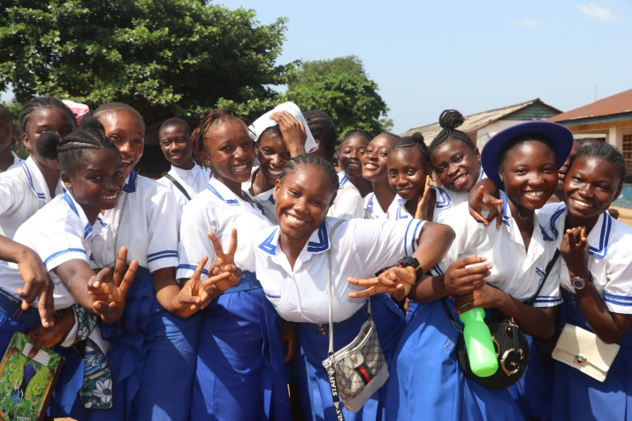
Confronting planet earth and to adopt a behavioral change. It is oobvious that human inducements such as deforestation, carbon emission, improper waste management, etc. have posed serious health and environmental threats to the achievement of the Sustainable Development Goals (SDGs) 13 (climate action), 14 (life below water) and 15 (life on land) respectively; however, many efforts have been integrated to mitigate and reduce the footprints of climate change which has been a major concern in Sierra Leone and the wider world.
Students of Minicipal Secondary School
It is believed that if we nurture the school pupils and learn to protect the environment; understand the impact of our actions and work together, we shall achieve a sustainable environment adequate for the well-being of all Sierra Leoneans.

